**Que 1. What are the advantages of Bootstrap?**

Ans.Benefits of using Bootstrap 1 Bootstrap 3, framework consists of Mobile first styles throughout the entire library instead them of in separate files. It is supported by all popular browsers. With just the knowledge of HTML and CSS, anyone can get started with Bootstrap. Bootstrap's responsive CSS adjusts to Desktops, Tablets, and Mobiles.

**Que 2. What is a Bootstrap Container, and how does it work?**

Ans. Bootstrap Containers are the most basic layout element in Bootstrap. Bootstrap Containers are very essential and basic building blocks of bootstrap that wrap a page’s content. It’s responsible for setting and aligning content within it according to viewport or given device. Containers are defined within the container class (.container). In other words, we can say that containers are established the width for the layout to give the content.

**Que 3.What are the default Bootstrap text settings?**

Ans. Default text size is 14px , Line Height is 1.428 , H1 36 px , H2 30px , H3 24px , H4 18px , H5 14px , H6 12px.

**Que 4. What do you know about the Bootstrap Grid System?**

Ans.Bootstrap Grid System is a collection of [HTML/CSS constituents](https://www.educba.com/html-vs-css/) that enables you to roll out a website and helps you in keeping its content at significant settings with ease. If you want to create a robust website layout, then this System could be the perfect choice to achieve it with an ability to quickly generate grid layouts for all kinds of mobile devices. It enables you to craft out columns and rows, thereby placing the data in the ‘intersected’ areas. The bootstrap grid system has the capacity to generate twelve columns and countless rows, also known as a twelve-grid system.

**Que 5. What is the difference between Bootstrap 4 and Bootstrap**

Ans. 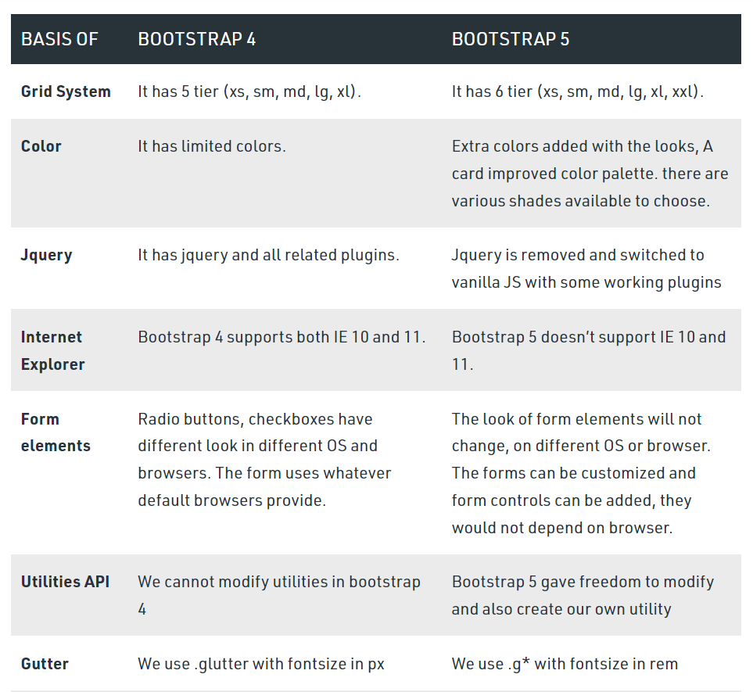

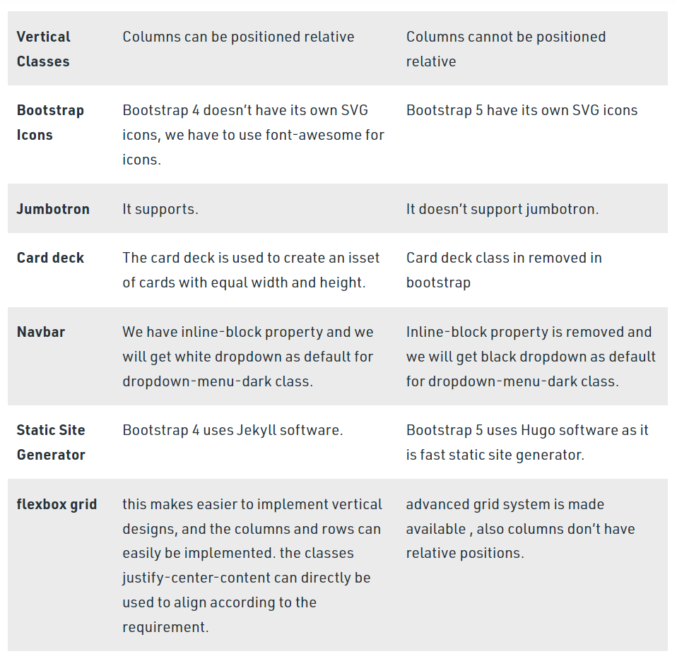

**Que 6.What is a Button Group, and what is the class for a basic Button Group?**

Ans.Button groups are useful when you want to place items like alignment buttons together. This allows multiple buttons to be stacked together on a single line. Description: Wrap a series of buttons with class**.btn** in .btn-group. This class is used for a basic button group.

**Que 7. How can you use Bootstrap to make thumbnails?**

Ans.A thumbnail is a small image that represents a larger image. Bootstrap has an easy way to do this with thumbnails. Bootstrap’s *.thumbnail*class is used to show linked images in grids ([grid system](https://www.geeksforgeeks.org/bootstrap-4-grid-system/)), a thumbnail is created using class *.thumbnail* within the element [<a>](https://www.geeksforgeeks.org/html-a-tag/#:~:text=HTML%20Tag,-Difficulty%20Level%20%3A%20Basic&text=The%20tag%20(anchor,as%20its%20%E2%80%9Chref%E2%80%9D%20value.).  The class *.col-sm-\**and *.col-md-\** (where * represent number ), it is used to create grids of the images.

**Que 8.In Bootstrap 4, what is flexbox?**

Ans. In Bootstrap 4, flex box is used to control the layout and alignment specification of Bootstrap 4 components. This box makes it easier to design flexible responsive layout structures without using float or positioning attributes.

**Que 9.How can one create an alert in Bootstrap?**

Ans.The .alert class followed by contextual classes are used to display the alert message on website. The alert classes are: .alert-success, .alert-info, .alert-warning, .alert-danger, .alert-primary, .alert-secondary, .alert-light and .alert-dark. We can use .alert-warning to create warning notification alerts in bootstrap.

**Que 10. What is a bootstrap card and how would you create one?**

Ans. A card in Bootstrap 5 is a bordered box with some padding around its content. It includes options for headers, footers, content, colors, etc. Some example text some example text. John Doe is an architect and engineer A basic card is created with the .card class, and content inside the card has a .card-body class.

***\*\*\*\*\*\*\*\*\*\*THANK YOU \*\*\*\*\*\*\*\*\*\****